**Mr. Visca’s: Calculus (sec 5.4)**

**Chpt 5 – Day 5: Fundamental Theorem of Calculus**

The Fundamental Theorem of Calculus, Part 1

If *f* is continuous on [a,b], then the function

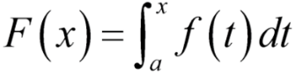

has a derivative at every point in [a,b], and

Let's apply this theorem using common sense...

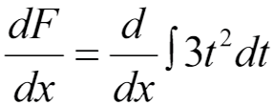

Find dF/dx.

1. Integrate 3t2

2. take derivative of result from step 1

*what about this t and x thing?*

***First Fundamental Theorem:***

1. Take the derivative of the integral:

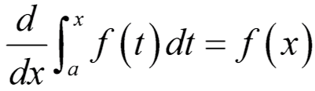

2. Derivative matches upper limit of integration:

3. Lower limit of integration is a constant:

Evaluate:

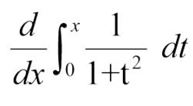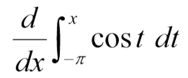

Now what obvious questions should you have???

**What if the upper limit is the constant and lower limit is the variable?**

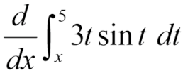

REMEMBER: _________________ the integral will

flip the upper and lower limits

**What if the derivative variable and upper limit do not match?**

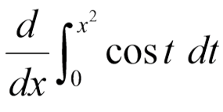

We can actually use the _____________________

**What if there is no constant for either limit?**

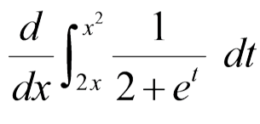

We ___________ the integral into ________________

***The Fundamental Theorem of Calculus, Part 2***

If *f* is continuous at every point of [a,b], and if

*F* is any antiderivative of *f* on [a,b], then

(Also called the **Integral Evaluation Theorem**)

**Homework: section 5.4**

pg. 302-303; 2-20 even, 30-38 even, 41, 43